SEQ (speech motor sequencing) experiment

This experiment was developed at the Guenther Lab at Boston University by Frank Guenther, Jennifer Segawa, Matt Masapollo, Andrew Meier, and Alan Bush. The Training phase of this experiment will be run remotely over Zoom and the Testing phase will be run in the OR intraoperatively while subjects undergo awake DBS implantation surgery. For questions, contact Alan Bush at alan.bush@mgh.harvard.edu.

Basic Information:

This is a speech motor learning experiment with a Training phase and a Test phase. In the first Training phase, which will be conducted remotely (Training I), native English-speaking subjects will be trained to proficiently speak single-syllable nonwords which contain onset consonant clusters that are not native to English (e.g. ‘ZDAT’). Another shorter Training session will later be conducted in person on the morning of surgery (Training II). The Test phase will be conducted while subjects are undergoing awake surgery for DBS implantation. In this Test phase, subjects will produce their learned non-native syllables, as well as novel non-native syllables and nonword syllables with English-native consonant clusters (e.g. ‘BRUG’). All phases of this experiment will be experimenter-paced. There is an additional Familiarization phase to be run if necessary before the first training run. It includes stimuli not used for the phases and should be used to ensure that the participants have a good understanding of the task.

Instructions for participant:

"In this experiment, you will hear a sound which is not an English word. That sound will also be spelled out on the screen. After you hear the beep, please repeat it aloud. Sometimes you will also hear a buzzer. If you hear the buzzer, stop saying whatever sound you are in the middle of saying. Try to say the exact sound you hear as quickly and accurately as possible. Please wait until you hear the beep to begin speaking."

Initial setup for Training I phase:

- Make sure the subject has the following ready to use at home:
  - A computer with Zoom installed
  - A microphone
  - Computer speakers which are not part of a headset (it’s important that the stimuli played through the subject’s speakers are also recorded by their microphone)
- Make sure that the experimenter has a computer with the following:
  - Two monitors
  - Speakers/headphones
  - A microphone
  - Zoom installed
  - Matlab (2019b or newer) with the Psychtoolbox installed
  - Task scripts and audio stimulus files (github.com/Brain-Modulation-Lab/Task_SpeechMotorSequenceLearning)
  - An external audio recorder cable cable of acquiring the audio output from the experimenter computer. (This will be used as backup if the Zoom recording fails).
- On the experimenter computer, if specfiles (files which determine the stimulus presentation order) have not yet been created for the subject, run stimListRandomizer.m in Matlab. This function must be run 3 times for each subject, once each for the Familiarization Phase, Training Phase, and Test Phase. This function takes the following ordered arguments:
    - Subject number
    - Stimulus group number; each subject should be assigned to a stimulus group from 1 to 5
    - Experiment phase (0 = Familiarization, 1 = Training, or 2 = Test)
    - Number of 5-minute blocks (full repetition of the stimulus list); in general, use 1 block for Familiarization, 10 blocks for Training I, 2 blocks for Training II, and 3 blocks for Test
- Test all scripts and recording functions on the experimenter computer prior to running the remote training session with subject

How to run the task:

- Open Matlab and in the directory containing the launcher scripts (START_SMLS_{phase}.m)
- Open Zoom and make sure that the following Zoom options (on the experimenter computer) in the Recording tab are set as follows:
  - check ‘Record a separate audio file for each participant who speaks’
  - uncheck ‘Record video during screen sharing’ (would need IRB AME to acquire video recordings)
- Start a Zoom meeting with the subject.
- Ask the subject to open up their Zoom settings:
  - On Mac, click on "zoom.us" on the menu bar to the right of the apple sign, in the top left corner of the screen. Select "preferences…".
  - On Windows, right click on the blue/white Zoom icon in the system tray on the bottom right of the screen:

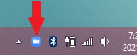
If this Zoom icon is not visible, click on the up-arrow in the system tray to find the Zoom icon:

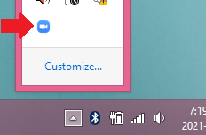

- Have the subject make sure that these Zoom options in their Audio tab are set as follows:
  - Suppress background noise:
---set to ‘Low’……… (if subject has lots of disruptive background noise, background noise suppression may be increased)
  - Microphone:
---uncheck ‘Automatically adjust microphone volume’
  - Music and Professional Audio:
---check ‘Show in-meeting option to “Turn On Original Sound”'
---uncheck ‘High fidelity music mode’
---check ‘Echo cancellation’ (this is counter intuitive, but this will disable echo cancelling. Read tooltip text.)
- Have the subject check that they have turned ON the Original Sound button at the top left of the Zoom screen; it should say “Turn Off Original Sound” (on Windows computers this button will also have turned blue):

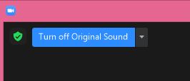

- Click the Zoom ‘Share Screen’ button
- Check the option to ‘Share sound’:



- Select the screen on which the stimuli will be presented (not the Matlab console screen), and click ‘Share’:

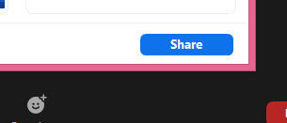

- Press the ‘Record’ button at the bottom of the Zoom screen:

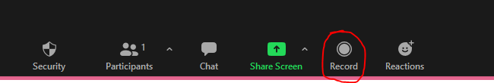

Make sure that it says ‘Recording’ in the upper left of the Zoom screen:

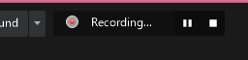

- Give the following instructions to the participant:

In this experiment, you will hear a sound which is not an English word. That sound will also be spelled out on the screen. After you hear the beep, please repeat it aloud. Sometimes you will also hear a buzzer. If you hear the buzzer, stop saying whatever sound you were in the middle of saying. Try to say the exact sound you hear as quickly as possible. Please wait until you hear the beep to begin speaking.

- Run STAR_SMSL_{phase}.m in Matlab command line to start the stimulus presentation function. The following prompt will appear:

- 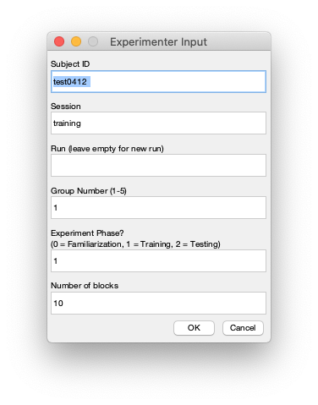

Enter the subject number and stimulus group. Enter 0 for the Experimenter Phase in order to start Familiarization
- Instruct the subject to follow the prompts on the screen and to speak clearly into their microphone
- Mute your (the experiment’s) microphone (on Windows, press Alt + A)
- Proceed through the 10 Familiarization trials. For each trial, press Spacebar to proceed once the subject has completed saying the syllable. You should be able to hear both the stimulus audio and the subject’s microphone.
- Unmute the experiment’s microphone
- If the subject had difficulties during Familiarization (such as too much epenthesis, not waiting until the GO cue, or not following STOP cues), instruct them on how to improve and rerun Familiarization until they perform the task correctly
  - For epenthesis, instruct the subject to say each sound as a single syllable
- Run SEQRun_DBS.m from the Matlab command line again, entering 1 as the Experiment Phase to start the Training phase
- Mute the experimenter’s microphone
- Proceed through all Training trials, pressing Spacebar the end of each trial
- During the designated automatic breaks, unmute your microphone and ask the participant if they want to take a break. Make sure to mute your microphone again before resuming running trials.
- Once the Training I phase is completed, end the Zoom meeting by clicking the red End button in the bottom right of the Zoom screen:

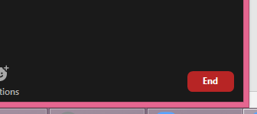

- Wait for Zoom to convert the recording. Once conversion is complete, choose a directory on your computer to save the recording into.

